AI Use Declaration Form
Course: Introduction to Artificial Intelligence
Lab Title: Lab 1 Part A — Uninformed Search Algorithms
Student Name:________Naa Adai Torto_________
Student ID: __________15022028___________
GitHub Repository Link: _________________________
Date Submitted: ___Saturday,20 th June ,2026___

1. AI Use Summary
Question | Student Response
Did you use any AI tool for this lab? | Claude and ChatGPT- study mode.
Estimated percentage of the work influenced by AI | %20
Did you attach evidence of AI use where applicable? | Yes

2. Details of AI Use
Complete the table below for each AI tool used. Add more rows where necessary.
Name of AI Tool Used | Purpose for Using the Tool | Prompt or Instruction Given to the Tool | Part(s) of the Work Influenced by the Tool | How I Verified, Edited, or Improved the AI Output
Claude | To help declare and correct an error in my code  To assist with creating my grid. | Please generate a 16 by 16 grid with zeroes and ones as values where 0 means free and 1 means obstacle. Let there be an interesting path | Forming my grids and proofreading the code. | I used the grid and gave it my desired goal and start.
ChatGPT | To help declare and correct an error in my code |  | Part A - IDS | I first wrote my code, asked for corrections, and then updated it.

3. Attachment of AI Output Evidence
Where required, attach evidence of AI use. Tick all that apply. Add more rows where necessary.
Evidence Type | Attached? (Yes, No, N/A) | File Name
AI-generated draft
Prompt history
Screenshot of AI interaction | yes
Exported AI conversation
AI-generated code snippet
Revised version showing student input
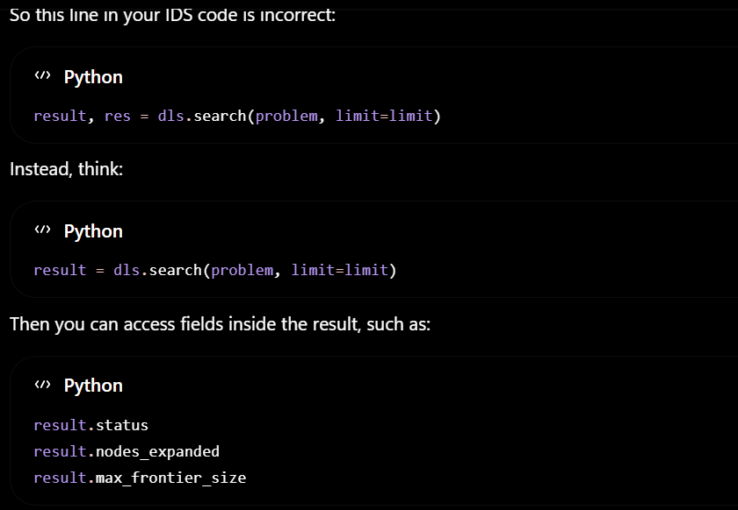
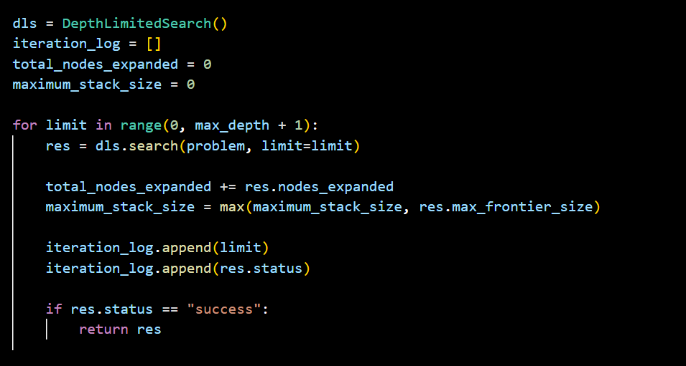
4. Student Declaration
I declare that:
Declaration Statement | Response (Yes/No)
The submitted work is my own work. | yes
Any use of AI tools has been clearly declared in this form. | yes
The prompts, instructions, and AI-generated outputs have been disclosed where applicable. | yes
I reviewed, tested, edited, and improved any AI-generated content before submission. | yes
My AI usage does not exceed 25% of the entire work. | yes
I understand that undeclared or excessive AI use may be treated as academic misconduct. | yes

Student Signature: _____Naa Adai Torto______________________________________
Date: _________20/06/2026__________________________________

